**Nanyang Technological University**

**School of Humanities and Social Sciences**

**Economics**

HE3004 Health Economy

**The Factors Affecting Vaccination Uptake in the United States (US)**

**Anurati Garg (U2031042F)**

**Chong Ker Wei Gerald (U2030807H)**

**Danish Aqid Bin Mohd Nizam (U2030635D)**

**Muhammad Irfan bin Norizzam (U2021872E)**

**Ng Jerrod (U2030652E)**

**Tan Yong Jun Jerell (U2030504L)**

Table of Contents

1. Introduction 3

1.1 Context of Research 3

1.2 Project’s Significance 3

1.3 Literature Review 4

1.4 Data and Methodology 5

1.4.1 Cleaning of Data 6

1.4.2 Approach: 6

2. Independent Variables 7

2.1 Median Age 7

2.1.1 Explanation of Regression Model 7

2.2 Race 8

2.2.1 Explanation of Regression Model 9

2.3 Healthcare Ranking 9

2.3.1 Explanation of Regression Model 9

2.4 Education Level 10

2.4.1 Explanation of Regression Model 10

2.5 Political Allegiance 11

2.5.1 Explanation of Regression Model 11

3. Individual Regression Outputs 12

3.1 Median Age 12

3.3 Healthcare Ranking 14

3.4 Education Level 15

3.5 Political Allegiance 16

4. Conclusion 18

4.1 Overall Regression 18

4.1.1 Overall Regression Model Explanation 18

4.2 Research Limitations 19

4.2.1 Lengthy Policy Implementation 19

4.2.2 Wilful Ignorance 19

4.2.3 Religion 20

4.3 Conclusion 21

# 1. Introduction

## 1.1 Context of Research

The COVID-19 pandemic is an unprecedented global event that is responsible for millions of deaths across the continent. For many countries, encouraging vaccination uptake is the main source of protection in helping to curtail the spread of the virus and to reduce the number of fatalities.

In the US, the spread of covid has been particularly damaging across major socio-economic sectors such as finance and manufacturing (Barlow and Vodenska, 2021). Thus, it has been an imperative objective for US officials to increase vaccination uptake in the country. As a developed country with abundant resources, the US struggles with a unique vaccine conundrum: there is an abundant supply of vaccines (Pfizer, 2021), but people are hesitant and resist taking them. Furthermore, the individual states in the US are incredibly fragmented and different (Subramanian, Kawachi et al., 2001). These factors cause the variables affecting vaccination uptake to differ on a state level, leading to a need for US officials to adopt a targeted approach to effectively increase vaccination uptake.

For brevity, vaccination in this research paper will henceforth refer specifically to Covid-19 vaccinations.

## 1.2 Project’s Significance

Taking into consideration the inherent differences in the demographics and vaccination uptake rates across states, we believe that identifying the different variables that affect vaccination on a state level is crucial in enabling the relevant authorities to adopt state-specific measures in increasing vaccination uptake. We will focus specifically on two main factors relating to vaccination uptake: accessibility[1] and hesitancy [2].

## 1.3 Literature Review

There has been extensive research done on the factors affecting vaccination uptake. Although the literature covers a wide range of factors identifying the problem, this review primarily focuses on two factors that emerge constantly throughout the literature we have reviewed. These factors are misinformation about the vaccine, and accessibility to obtain the vaccine.

Chou et al. (2021) suggest that online misinformation regarding the COVID-19 has undermined public health efforts to control the coronavirus. A study that was conducted recently has mirrored this sentiment. For instance, internet-based sources produced 90.50% of all misinformation relating to the coronavirus, of which social media (84.94%) produced the highest (Al-Zaman, 2022). This suggests that misinformation about vaccination is widespread and will be difficult to filter due to its huge presence in social media. Thus, anti-vaccination sentiments will be prevalent if such problems continue to persist which lead to hesitancy.

Su et al. (2021) argues that not everyone will have the same level of access to vaccines even though the production of the vaccines has elevated access globally. The issue of inequitable access exists globally because of vaccine hoarding. For instance, Canada bought an oversupply of vaccines that covers more than 5 times its population, resulting in people in third world countries being more vulnerable and unimmunized (Doucleff, 2020). Thus, if vaccine accessibility remains inequitable, vaccination uptake will be affected adversely.

Although existing literature covers a wide range of variables, there is significantly fewer research done on the variables affecting vaccination uptake specifically in the context of the US. Furthermore, majority of research done in the context of the US focus on the variables affecting vaccination on a national level. For example, Graupensperger et al. (2021) collected only aggregated, national data to evaluate college students’ sentiments towards vaccination. Meanwhile, in Fridman, Gershon et al. (2021), a longitudinal survey of residents in the US was conducted over six months to identify the causes of vaccination hesitancy. While there are multiple variables that were identified to affect vaccine hesitancy in the US, the survey data was also collected on a national level instead of state level. These research data have minimal significance in helping US officials to conduct a targeted approach on a state level, which is more effective given the differing state demographics in the US.

To address these gaps, our research will delve deeper into state-specific variables that affect vaccination uptake. This will equip the relevant authorities with the ability to adopt a more effective, state-tailored, policy approach to tackle vaccination accessibility and hesitancy.

## 1.4 Data and Methodology

The data that our group used to identify the different variables that affect vaccination on a state level, are the following:

|  |  |
| --- | --- |
| Dependent Variable | Percentage of Vaccination Uptake by State (Numerical Variable) |
| Independent Variables | Median Age by State (Numerical Variable) |
| Race Breakdown by State (Numerical Variable)   * Percentage of White Community * Percentage of Black Community |
| Healthcare Ranking by State (Numerical Variable) |
| Percentage of Bachelor’s Educated by State (Numerical Variable) |
| Political Allegiance by State (Categorical Variable)   * Political Allegiance Democratic Trifecta * Political Allegiance Divided Trifecta * Political Allegiance Republican Trifecta |
| Control Variable | Population by State |

Population was introduced as a control variable and is held constant throughout the project to ensure that the experiment results obtained through the various regressions are fair and reliable.

### 1.4.1 Cleaning of Data

Before using the data, “cleaning” of the datasets was done to ensure that subsequent results and graphs obtained are accurate and unaffected by anomalies. This “cleaning” involves observing outliers within the datasets that need to be extracted as well as manipulating the units of the variables to ensure that the regressions can be done, and the resulting accuracy of the results collected is reliable.

### 1.4.2 Approach:

We first plotted individual graphs and the regression line of the various independent variables against the percentage of Vaccination uptake (Dependent Variable). This allows one to see a general trend and correlation between the variables.

Afterwards, we constructed Regressions of the independent variables with population as the control variable against the Dependent Variable to obtain the coefficients that allows one to observe the effect a unit change of an independent variable has against the Dependent Variable.

Finally, by constructing an overall multivariate regression including all variables, we can observe which factor will have the greatest effect on influencing Vaccination Uptake in the US.

# 2. Independent Variables

## 2.1 Median Age

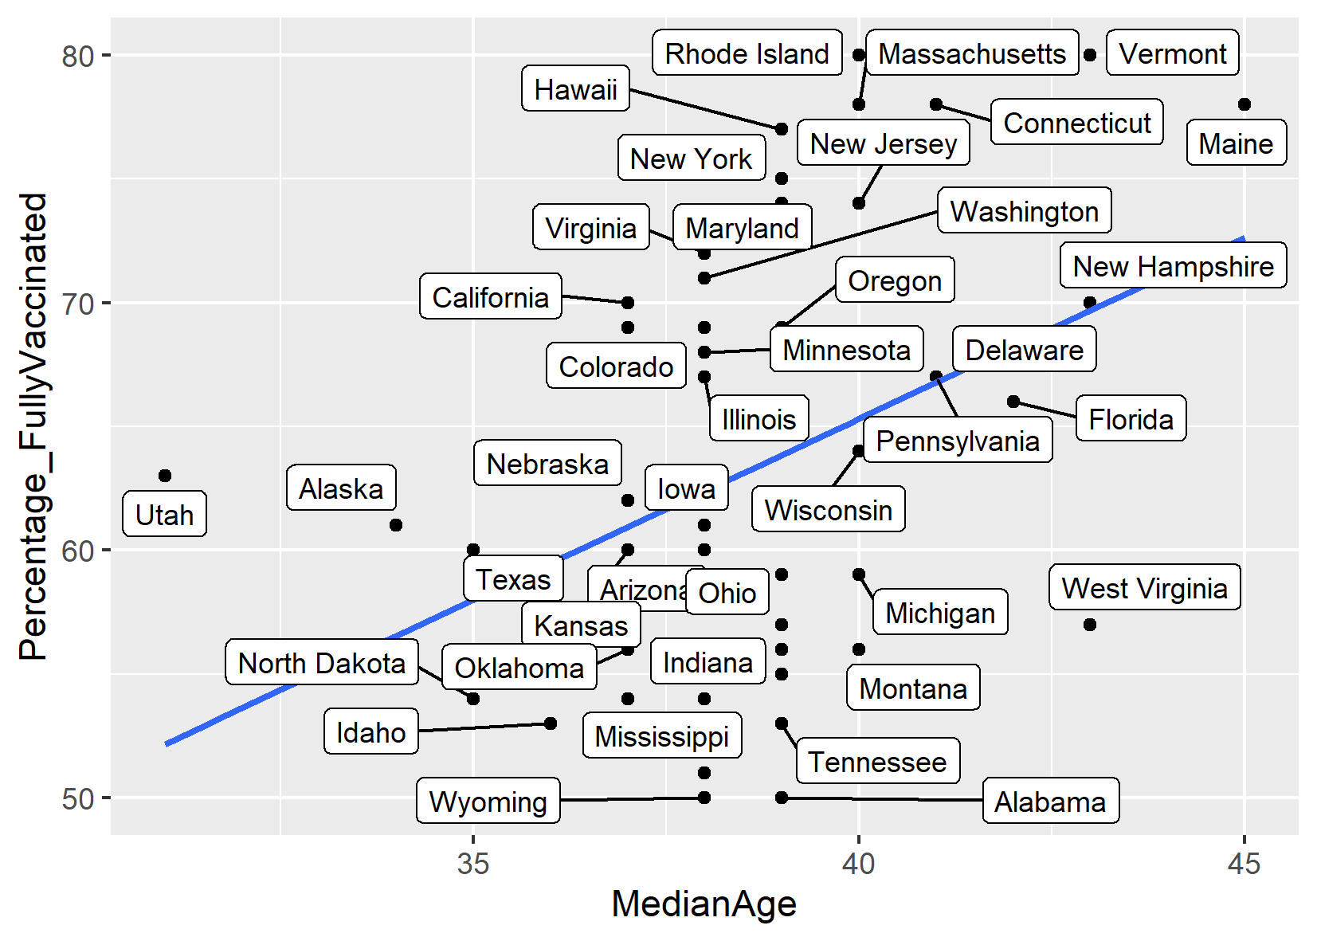

Figure 1: Graph of Vaccination Uptake against Median Age

### 2.1.1 Explanation of Regression Model

In our regression model, median age refers to age that divides the population into two parts of equal size, that is, there are as many persons with ages above the median as there are with ages below the median. The upward trend shown in Figure 1 could be linked to the increased efforts and campaigns in elderly aid.

## 2.2 Race

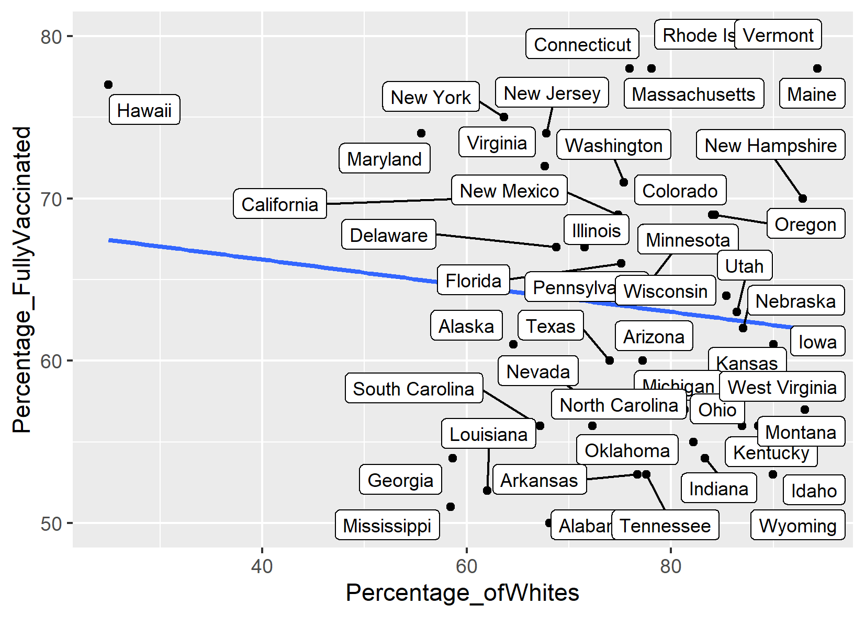

Figure 2: Graph of Vaccination Uptake against Percentage of White Community

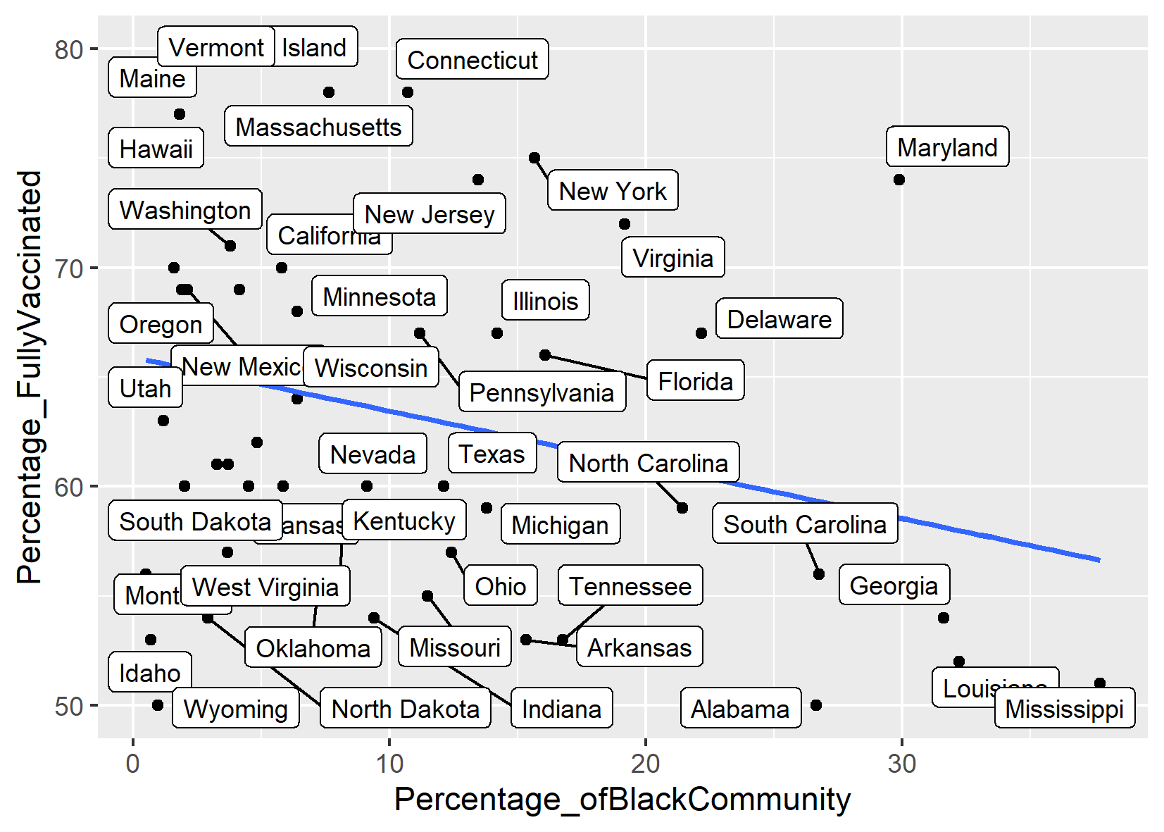

Figure 3: Graph of Vaccination Uptake against Percentage of Black Community

### 2.2.1 Explanation of Regression Model

In the regression models we use race i.e., ethnic differences as our variable. The two races we consider are black and white. We can see a downward trend for both the black and white race. This downward trend is explained by two factors of barriers: access and hesitancy.

## 2.3 Healthcare Ranking

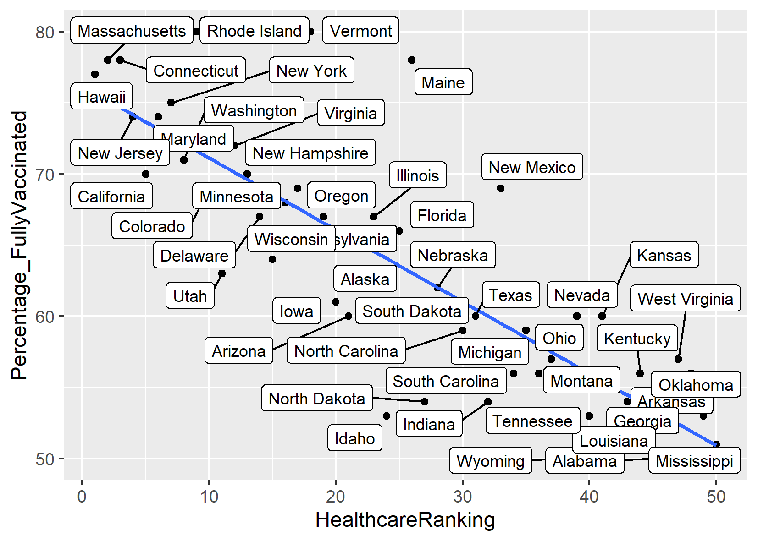

Figure 4: Graph of Vaccination Uptake against Healthcare Ranking

### 2.3.1 Explanation of Regression Model

In our regression model, healthcare ranks of states are based on healthcare quality, healthcare accessibility and overall public health. Figure 4 shows a downward trend as we move up along the ranks. Since a widely available vaccine is the best tool for infectious disease control (Fisk, 2020), this trend is likely caused by vaccine availability in the respective states.

## 2.4 Education Level

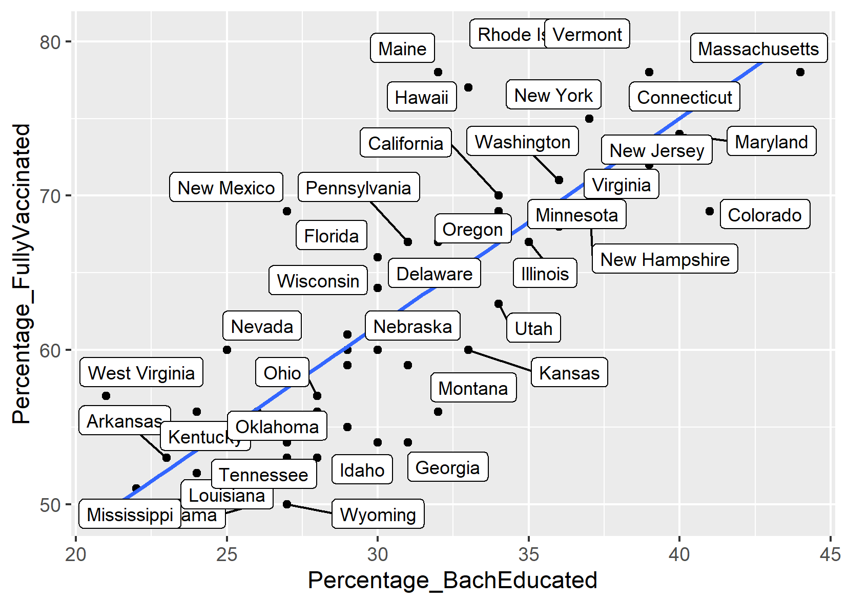

Figure 5: Graph of Vaccination Uptake against Percentage of Bachelor's Educated

### 2.4.1 Explanation of Regression Model

The percentage of vaccination uptake against percentage bachelor educated in Figure 5 shows an upward trend. It could be explained using 2 main factors, namely, the over perception of costs and under perception of benefits (Darling and Thomas, 2021), and the increase in hesitancy among the lower educated (Khairat et al, 2022).

## 2.5 Political Allegiance

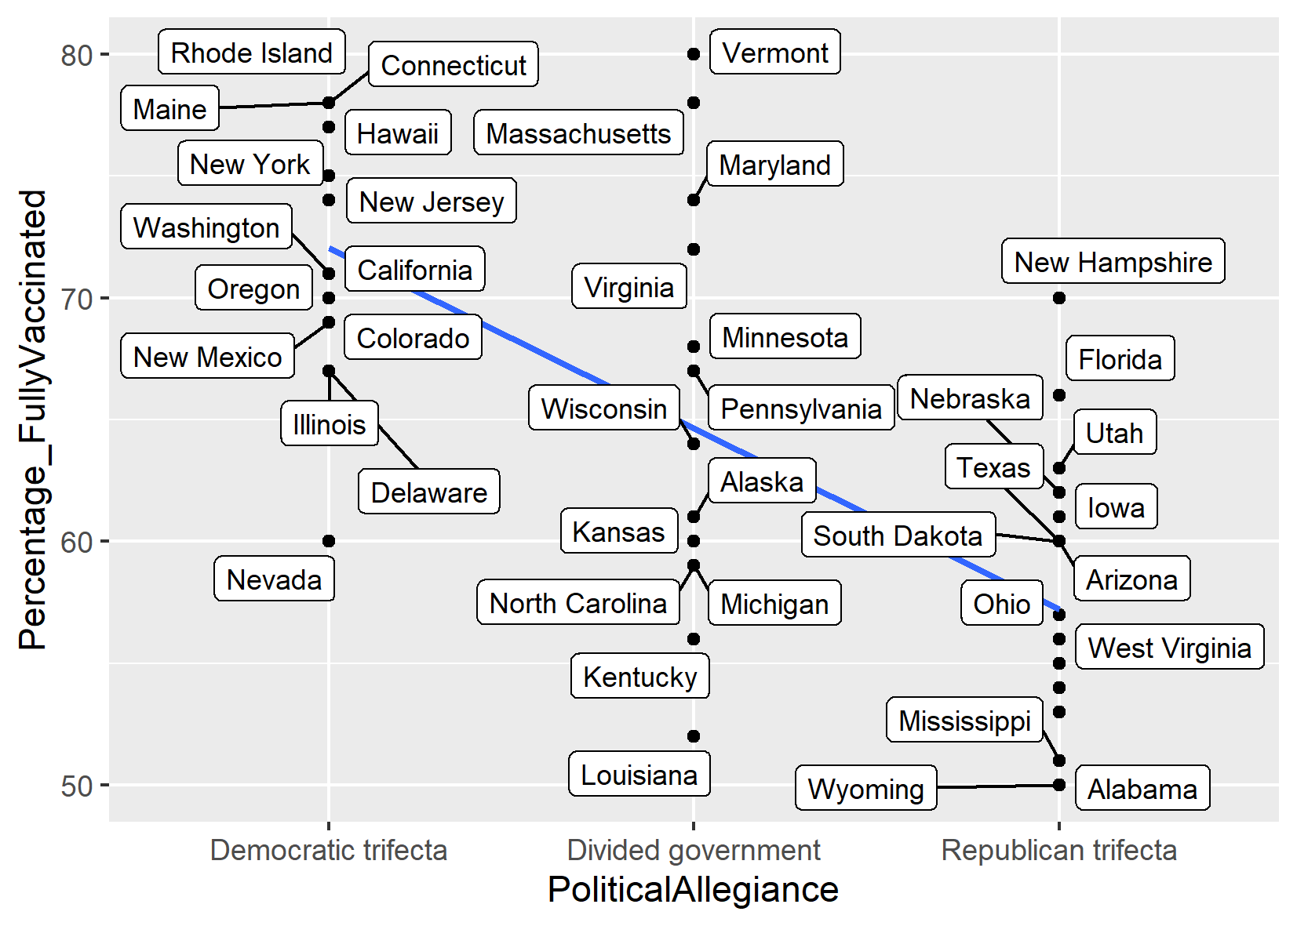

Figure 6: Graph of Vaccination Uptake against Political Allegiance

### 2.5.1 Explanation of Regression Model

Political allegiance variable in our case refers to the main governing body of the state trifecta which refers to the state’s government, house and senate.

Figure 6 shows a downwards trend as the trifecta goes from Democratic to Republican.

This trend is observed due to 2 possible reasons, political motivations which refers to the active advocacy of the vaccines by democratic leaders (Brownstein, 2021), and the exposure to false and inaccurate news by the media (Hamel et al., 2021).

# 3. Individual Regression Outputs

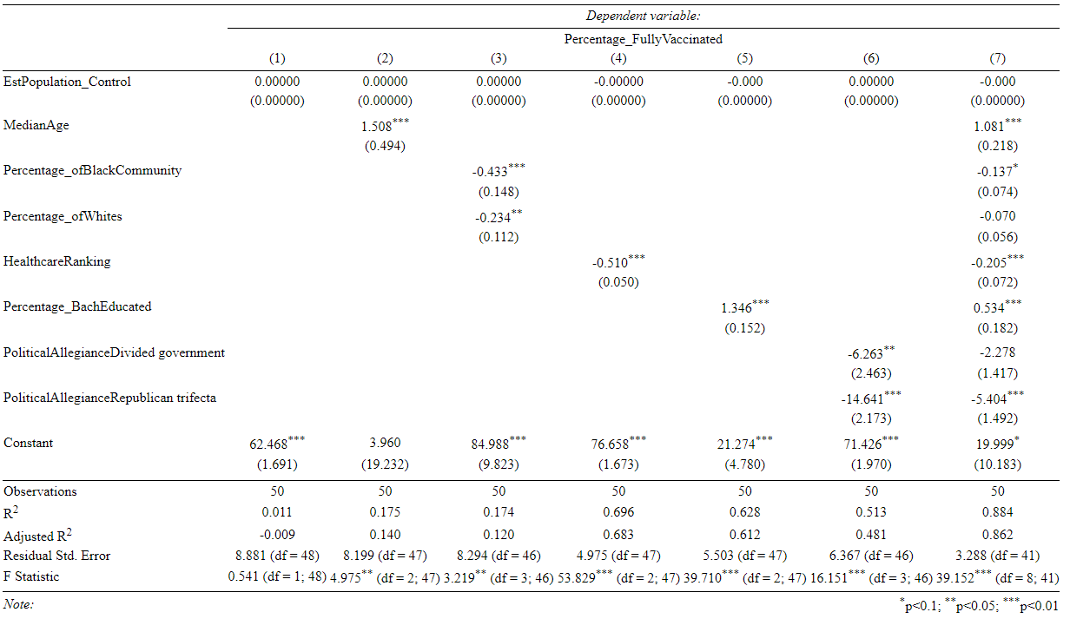

Table 1: Regression Table

Table 1 shows all the individual regressions of percentage of Vaccination Uptake against the various independent variables mentioned earlier as well as a final regression involving all factors to examine which independent variable remains significant in influencing the percentage of Vaccination uptake.

It is seen that the coefficient of the population variable which is added in our regressions as a control variable is 0 for all the regressions, which means that population has no effect on the impact of our regressions.

## 3.1 Median Age

A coefficient of 1.461 means that for every 1 increase in the median age of the group, there will be a 1.461 percent increase in the uptake of vaccination. Generally, elderly persons are the group with the highest risk of morbidity and mortality. As a result, it makes sense that there are more efforts targeted at this group for immunization to alleviate more suffering and save more lives. This was mainly conducted through a tailored and targeted outreach. By reaching out with accessible and culturally competent information, and partners and trusted sources, they spread the word to elderlies and seniors with disabilities, rather than expecting them to search for this information. Also, the Multiple Area Agency on Aging (AAA) has been coordinating with the state department of health and health care providers to identify and reach underserved older adults including people who are homebound or have limited English proficiency (Strategies for Helping Older Adults and People with Disabilities Access COVID-19 Vaccines, 2021). From this, it shows elderly-focused efforts by the government. Hence, future policies could start to explore ways to increase uptake of vaccines by the young instead.

3.2 Race

A coefficient of -0.433 means that for 1% increase for Black people the vaccination uptake goes down by 0.433%. This is a result of both hesitancy and limited access. Access refers to structural limitations, such as far-flung vaccination sites, a lack of transportation, and rigid work hours, obstructing vaccine usage, particularly among disadvantaged populations. Because lack of accessibility has a negative impact on vaccination uptake, the government should focus on enhancing accessibility for Black-dominated states. Vaccination hesitancy among African-Americans has been attributed in part to a long-standing distrust of the US medical system (Artiga, 2021). Due to widespread prejudice in the medical community, Black people are shown to have a lower level of faith in the US government and health-care system.

For every 1 % increase in Whites, vaccination rate falls by -0.427%. However, the only factor for this is hesitancy, as white people have been proven to have more accessibility compared to Black people. So, in White-dominated states, the government should not over-invest in making vaccination more accessible as it is not the main issue. White people are concerned with preserving their right to freedom and choice by avoiding any vaccine mandates. Even the Republican party that has opposed the vaccine mandate is predominantly White.

Figure 7 shows a scale of racial equitable vaccine distribution. In the figure, the darker the colour the more equitable the vaccine distribution between races. In the 23 states that tracked the race or ethnicity of those vaccinated, even though Whites are also hesitant, they were still getting vaccinated at disproportionately high rates (Dottle & Tartar, 2021)

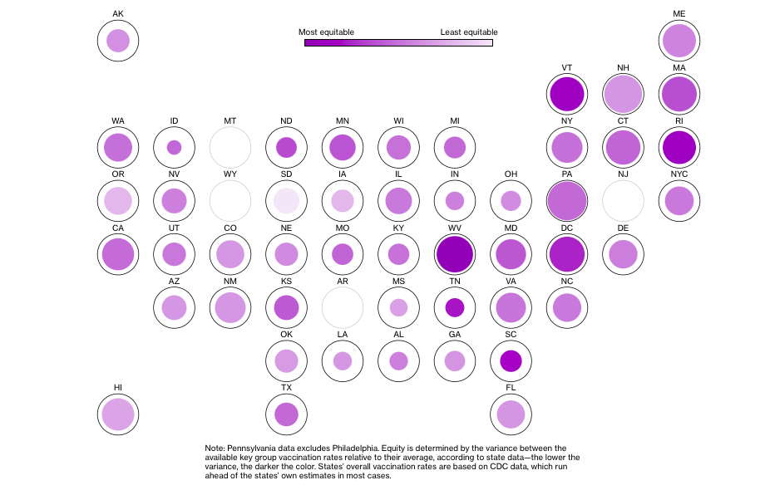Figure 7: Plot to show Vaccine Distribution Equitability at State Level

## 3.3 Healthcare Ranking

The regression of percentage vaccinated on healthcare ranking has a negative coefficient of -0.510. This means that for every increase of 1 spot on the healthcare ranking (total of 50), there will be a 0.510 decrease in percentage of fully vaccinated.

As mentioned earlier, when it comes to healthcare, accessibility is the main issue. At the state level, mean driving distance to the nearest covid-19 vaccination facility is 2.8 miles, and the mean driving distance to the closest facility was highest in Montana (8.3), South Dakota (6.5), Wyoming (5.9), North Dakota (5.8), and Nebraska (4.0) (Berenbrok, et al, 2021). These 5 states are also ranked poorly and have significantly low percentage uptake based on Figure 4. Also, rural areas are a cause for concern too. For instance, the Rural Policy Research Institute found that 111 rural counties have no brick-and-mortar pharmacies that can provide the vaccines (Hawryluk, 2021). This might explain why some states have a significantly low vaccination uptake, since citizens may find it troublesome to travel far just to get vaccinated. To tackle this issue, government bodies in respective states have to recognise if their state is affected by distance issues or not. A possible solution for affected states would be that they can roll out mobile vaccination units to hard–to-reach areas which hopefully increases the vaccination uptake.

## 3.4 Education Level

The regression of percentage of fully vaccinated people on percentage of bachelor's educated has a coefficient of 1.344. This means that for one percentage increase in percentage of bachelor's educated, there will be a 1.344 increase in percentage of fully vaccinated uptake. Individuals with education level below a bachelor's degree tend to underestimate the efficiency and overestimate the side effects of vaccination (Miller, 2021). Data from CDC on the age adjusted crude incidence rate for the fully vaccinated is 177.7 per 100,000 which is 0.177% and the reported rate of severe side effects like Anaphylaxis is 5 per 1,000,000 which is extremely low. Also, the reported rates of other severe side effects retrieved from CDC are similarly extremely low, much smaller than 1%. From Table 2, individuals with at least a bachelor's degree estimated the chance of a vaccinated person still getting covid-19 to be 23% and estimated 15% for chance of serious side effects. This is compared to 34% and 30% respectively for individuals with less than a bachelor's degree. Comparing to the actual data, both groups of individuals have overestimated the breakthrough rate and chance of side effects of the vaccine and are not getting the vaccine. However, the less educated have a higher error in perception. The higher educated have a perception closer to the actual data which aligns their private benefit and cost of the vaccine closer to the actual value, where they can make more informed choices and are more inclined in taking the vaccination.

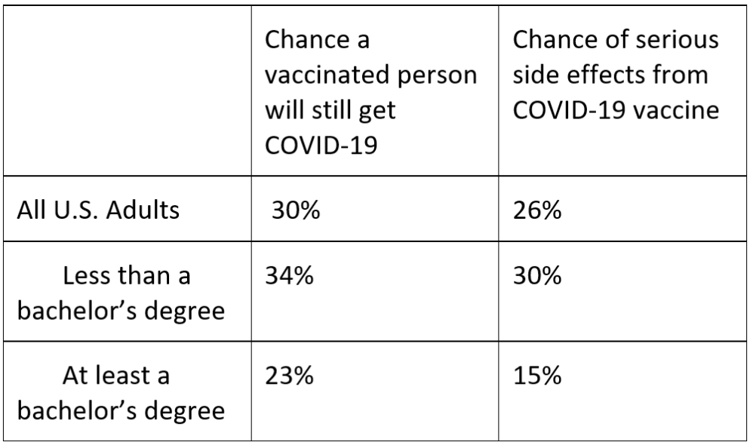

Table 2: Table of impact of vaccination on Covid-19

The low uptake in vaccination amongst the lower educated is also due to the large amount of hesitancy associated with it (Khairat et al, 2022). Figure 8 shows the top 10 factors of hesitancy which is important when targeting the high hesitancy aggregated as a country. However, the government must employ tailored policies for specific factors based on individual state data. For example, if the lack of trust in the government is the main factor, then having a minister persuade vaccination uptake would not be efficient and could be counterproductive.

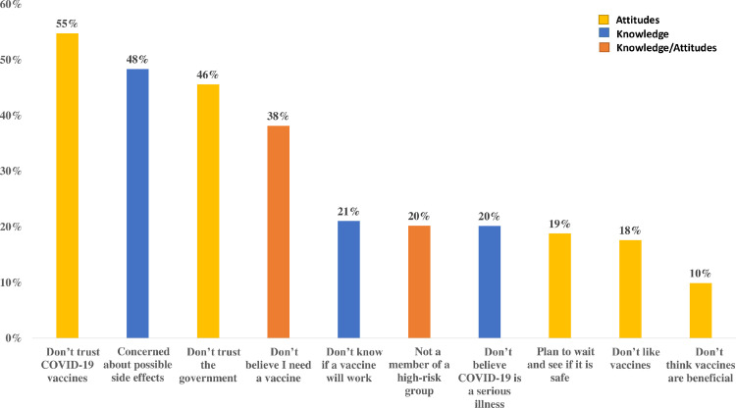

Figure 8: Factors of Hesitancy towards Covid-19

Additionally, a key insight is that the higher educated are also overestimating the breakthrough rate and severe side effect rate. Where suggestions for education policy intervention have been recommended to focus mainly on the lower educated (Miller, 2021), excluding the importance of the higher educated. However, from the key insight, targeting education, the government should also focus on the higher educated, as there are still large gaps in knowledge amongst them which could increase vaccination rate when covered.

## 3.5 Political Allegiance

The regression of Percentage of Vaccination uptake against Political allegiance, a Divided Trifecta will have a 6.3% decrease in vaccination uptake while the Republican Trifecta will have a 14.7% decrease in vaccination uptake compared to a Democratic Trifecta respectively.

As stated earlier, there are 2 possible reasons for the results, political motivations, and exposure to media.

Firstly, regarding political motivations, democratic representatives actively advocate for the vaccines to be taken. The republican representatives, however, do not actively advocate for this and instead advocate for freedom of choice which would result in lower vaccine uptake numbers among republicans (Brownstein, 2021).

Secondly, exposure to the media. Majorities of Democrats say they trust information about COVID-19 from network news and CNN, while Republicans’ most trusted sources of COVID-19 information is Fox News (Hamel et al., 2021), which previously had cases of inaccurate reporting and does not filter out conspiracy theories well. An example is the spread of news regarding Ivermectin, a drug used for parasitic worms, that could be used as a Covid-19 cure even when government agencies say otherwise (Darcy, 2021). This would explain why 84% of Republicans believe or have apprehensions that the extent of the impact of covid-19 is exaggerated by the government compared to just one third of Democrats. Because of this belief in conspiracy theories, this increases the hesitancy amongst republicans towards vaccination uptake resulting in the observed results.

A possible intervention that can be taken is to strongly enforce a filter on the media to ensure that the news disseminated is accurate to prevent misinformation amongst the public albeit infringing on the freedom of speech in America.

# 4. Conclusion

## 4.1 Overall Regression

|  |  |  |
| --- | --- | --- |
| **Independent**  **Variable** | **Individual Regression Coefficient** | **Final Multivariate Regression Coefficient** |
| **Median Age** | 1.508*** | 1.081*** |
| **Percentage of Black Community** | -0.433*** | -0.137* |
| **Percentage of Whites** | -0.234** | -0.070 |
| **Healthcare Ranking** | -0.510*** | -0.205*** |
| **Percentage of Bachelor’s Educated** | 1.346*** | 0.534*** |
| **Political Allegiance Divided Government** | -6.263** | -2.278 |
| **Political Allegiance Republican Trifecta** | -14.641*** | -5.404*** |

where *p<0.1, **p<0.05, *** p<0.01

Table 3: Table of changes in Coefficient from Table 1

### 4.1.1 Overall Regression Model Explanation

From Table 3, the coefficients of all the independent variables against Vaccination uptake tends towards 0 when comparing the Individual Regressions with the Final Multivariate Regressions. This is logical as the changes in the coefficients is due to more factors being considered in the regression calculations, thus, the effect of any single independent variable will be minimised causing each coefficient to tend more towards 0.

The independent variables: Median Age, Healthcare Ranking, Percentage of Bachelor's Educated, and Political Allegiance Republican Trifecta is still highly statistically significant at p<0.01.

As for the independent variable, Percentage of Black Community, it’s significance has reduced from p<0.01 to p<0.1. While the variables, Percentage of Whites and Political Allegiance Divided Government that was Statistically significant at p<0.05 is now no longer statistically significant.

From the above observations, it is evident that the factors that affects Vaccination Uptake the most in the United States of America are the following:

* Median Age
* Healthcare Ranking
* Percentage of Bachelor's Educated
* Political Allegiance

Of which the most influential factor with the highest coefficient, is Political Allegiance.

## 4.2 Research Limitations

As with every research, there are limitations to our research that we acknowledge. Below are several factors of limitations to our research.

### 4.2.1 Lengthy Policy Implementation

It is generally difficult to change policies because institutions are sticky, and actors protect the existing model even if it is suboptimal (Greener, 2002). Thus, for policy changes to occur, tremendous time and effort need to be invested. This calls into question the relevance of the data obtained due to time lag as alternative forms of medicine—which may render vaccinations useless—may be developed in the future. Additionally, it is possible that vaccination uptake becomes irrelevant in subsequent time periods due to circumstances such as herd-immunity.

### 4.2.2 Wilful Ignorance

According to research done by Ipsos MORI, America is the developed world's second most ignorant country (Ipsos MORI, 2018). Many Americans take inaccurate media as gospel and pseudohistory as the truth. This causes them to suffer from complacency, arrogance and pride. These factors make Americans resistant to changing their mindset on vaccination uptake, which may limit the effectiveness of any approach that aims to increase vaccination uptake.

### 4.2.3 Religion

Wealthier countries tend to be less religious, but the US is a prominent exception with 54% saying religion plays a very important role in their lives, as shown in Figure 9.

Figure 9: Graph Showing Percentage of People Saying Religion Plays a Very Important Role in Their Lives by Country

Religion is often a major source of anti-vaccination sentiments. To illustrate, Christian nationalism is negatively related to the odds of vaccine uptake (Corcoran, Scheitle et al., 2021), with many cherry-picking religious scriptures as grounds for refusing to take the vaccine. This may inhibit the effectiveness of policies that aim to increase vaccination uptake as it is difficult to change sentiments grounded in religion.

## 4.3 Conclusion

Despite the limitations mentioned above, we believe that it is still important to identify the different variables affecting vaccination uptake on a state level. To effectively combat vaccine hesitancy, a multi-pronged approach through varied channels will be important. The government should take into consideration the data of the various independent variables and their relevant regression model outcomes. This allows them to utilise the data by turning it into actionable programmes to effectively increase vaccination uptake.

We believe our targeted research will be a strong enabler for the US government to increase vaccination uptake through a state-tailored approach, which is paramount in the fight against Covid-19.

**References:**

Al-Zaman, M. S. (2022). *Prevalence and source analysis of COVID-19 misinformation in 138 countries*. from <https://journals.sagepub.com/doi/full/10.1177/03400352211041135>

Artiga, S. (2021, 16 juli). *Health Coverage by Race and Ethnicity, 2010–2019*. KFF. <https://www.kff.org/racial-equity-and-health-policy/issue-brief/health-coverage-by-race-and-ethnicity/#:~:text=People%20of%20color%20were%20at,to%20affordable%20health%20coverage%20options>

Barlow, J., & Vodenska, I. (2021). Socio-economic impact of the covid-19 pandemic in the U.S. Entropy (Basel, Switzerland), 23(6), 673. <https://doi.org/10.3390/e23060673>

Berenbrok, L. A., Tang, S., Coley, K. C., Boccuti, C., Dickson, S., & Hernandez, I. (2021). Access to potential COVID-19 vaccine administration facilities: a geographic information systems analysis. *Report. University of Pittsburgh School of Pharmacy,* from <https://www.westhealth.org/wp-content/uploads/2021/02/Access-to-Potential-COVID-19-Vaccine-Administration-Facilities-2-2-2021.pdf>

Brownstein, R. (2021, August 12). *‘Everybody I know is pissed off’*. The Atlantic. Retrieved April 15, 2022, from<https://www.theatlantic.com/politics/archive/2021/08/vaccine-mandates-republicans-democrats/619735/>

Chou, W. Y. S., Gaysynsky, A., & Vanderpool, R. C. (2021). The COVID-19 misinfodemic: Moving beyond fact-checking. *Health Education & Behavior*, *48*(1), 9-13. <https://pubmed.ncbi.nlm.nih.gov/33322939/>

Corcoran, K. E., Scheitle, C. P., & DiGregorio, B. D. (2021). Christian nationalism and COVID-19 vaccine hesitancy and uptake. Vaccine, 39(45), 6614-6621. <https://doi.org/10.1016/j.vaccine.2021.09.074>

Countries. *IFLA Journal*, *48*(1), 189-204. <https://journals.sagepub.com.remotexs.ntu.edu.sg/doi/full/10.1177/03400352211041135>

Darcy, O. (2021, August 23). *Right-wing media pushed a deworming drug to treat COVID-19 that the FDA says is unsafe for humans*. CNN. Retrieved April 15, 2022, from<https://edition.cnn.com/2021/08/23/media/right-wing-media-ivermectin/index.html>

Dottle, R., & Tartar, A. (2021, 16 december). *Half of U.S. States Have Big Racial Vaccine Gaps Heading Into Omicron*. Bloomberg. Geraadpleegd op 16 april 2022, van <https://www.bloomberg.com/tosv2.html?vid=&uuid=c81dd3a2-bd8f-11ec-8779-484c576f4a54&url=L2dyYXBoaWNzL2NvdmlkLXZhY2NpbmUtdHJhY2tlci1nbG9iYWwtZGlzdHJpYnV0aW9uL3VzLXZhY2NpbmUtZGVtb2dyYXBoaWNzLmh0bWw=>

Doucleff, M. (2020). *How rich countries are 'hoarding' the world's vaccines, in charts*. NPR, from <https://www.npr.org/sections/goatsandsoda/2020/12/03/942303736/how-rich-countries-are-hoarding-the-worlds-vaccines-in-charts?t=1607496526830>

Fridman, A., Gershon, R., & Gneezy, A. (2021). COVID-19 and vaccine hesitancy: A longitudinal study. PLoS One, 16(4), e0250123. <https://doi.org/10.1371/journal.pone.0250123>

Graupensperger, Abdallah, D. A., & Lee, C. M. (2021). Social norms and vaccine uptake: College students’ COVID vaccination intentions, attitudes, and estimated peer norms and comparisons with influenza vaccine. Vaccine, 39(15), 2060–2067. <https://doi.org/10.1016/j.vaccine.2021.03.018>

Greener, I. (2002). Understanding NHS Reform: The Policy-Transfer, Social Learning, and Path-Dependency Perspectives. *Governance (Oxford)*, *15*(2), 161-183. <https://doi.org/10.1111/1468-0491.00184>

Hamel, L., Lopes, L., Kirzinger, A., Sparks, G., Stokes, M., & Brodie, M. (2021, November 8). *KFF COVID-19 vaccine monitor: Media and misinformation*. KFF. Retrieved April 15, 2022, from <https://www.kff.org/coronavirus-covid-19/poll-finding/kff-covid-19-vaccine-monitor-media-and-misinformation/>

Hawryluk, M. (2021). *Rural Americans in pharmacy deserts hurting for covid vaccines*. Kaiser Health News, from <https://khn.org/news/article/rural-america-pharmacy-deserts-hurting-for-covid-vaccine-access/>

Ipsos MORI. (2014, October 29). Perceptions are not reality: Things the world gets wrong | Retrieved April 10, 2022, from <https://www.ipsos.com/en-uk/perceptions-are-not-reality-things-world-gets-wrong>

Khairat, S., Zou, B., & Adler-Milstein, J. (2022, March). Factors and reasons associated with low COVID-19 vaccine uptake among highly hesitant communities in the US. Retrieved April 17, 2022, from <https://www.ncbi.nlm.nih.gov/pmc/articles/PMC8730806/#:~:text=as%20attitudes%2Fknowledge.-,The%20most%20common%20reason%20driving%20vaccine%20hesitancy%20was%20lack%20of,was%20related%20to%20vaccine%20access.&text=.,-Top%2010%20reasons>

Miller, J. (2021, February 26). Education is now a bigger factor than race in desire for covid-19 vaccine. Retrieved April 17, 2022, from <https://news.usc.edu/182848/education-covid-19-vaccine-safety-risks-usc-study/>

Pew Research Center. (2015, March 13). Wealthier nations less religious; U.S. an exception. Retrieved April 10, 2022, from <https://www.pewresearch.org/fact-tank/2015/03/12/how-do-americans-stand-out-from-the-rest-of-the-world/ft_15-03-10_religiousgdpscatter/>

Pfizer. (2021, July 23). Pfizer and BioNTech to provide U.S. government with an additional 200 million doses of COVID-19 vaccine to help meet continued need for vaccine supply in the U.S. Retrieved April 17, 2022, from <https://www.pfizer.com/news/press-release/press-release-detail/pfizer-and-biontech-provide-us-government-additional-200>

Strategies for helping older adults and people with *...* (n.d.). Retrieved April 16, 2022, from <https://acl.gov/sites/default/files/2021-04/ACLStrategiesVaccineAccess_Final.pdf>

Su, Z., McDonnell, D., Cheshmehzangi, A., Li, X., Maestro, D., Šegalo, S., ... & Hao, X. (2021). With great hopes come great expectations: Access and adoption issues associated with COVID-19 vaccines. *JMIR Public Health and Surveillance*, *7*(8), e26111. <https://publichealth.jmir.org/2021/8/e26111/>

Subramanian, S. V., Kawachi, I., & Kennedy, B. P. (2001). Does the state you live in make a difference? Multilevel analysis of self-rated health in the US. Social science & medicine (1982), 53(1), 9-19. <https://doi.org/10.1016/S0277-9536(00)00309-9>

Thomas, K., & Darling, J. (2021, March 04). Education is now a bigger factor than race in desire for covid-19 vaccine. Retrieved April 17, 2022, from <https://healthpolicy.usc.edu/evidence-base/education-is-now-a-bigger-factor-than-race-in-desire-for-covid-19-vaccine/>

1. Vaccination Accessibility: structural limitations, such as far-flung vaccination sites, a lack of transportation, and rigid work hours, obstructing vaccine usage
2. Vaccination Hesitancy: the unwillingness or reluctance in accepting vaccinations despite their availability